DUMMIES BOOK COVER ASSIGNMENT
Your task is to create a “for Dummies” book cover using Photoshop. The cover must be set up in the traditional “Dummies” style (yellow background, black rectangle, “Dummies” smarty guy (you must design a custom guy using the pen tool), image, and shape with text. And, you are the “author” of this masterpiece! See scoring guide for details.
Parody covers: 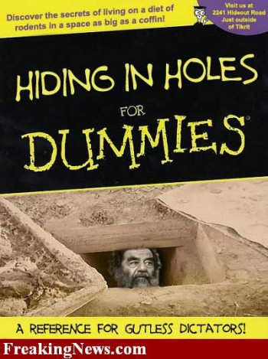 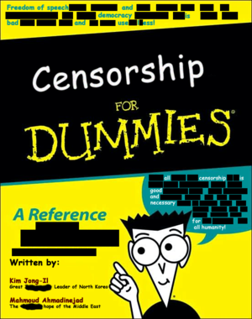
Real covers: 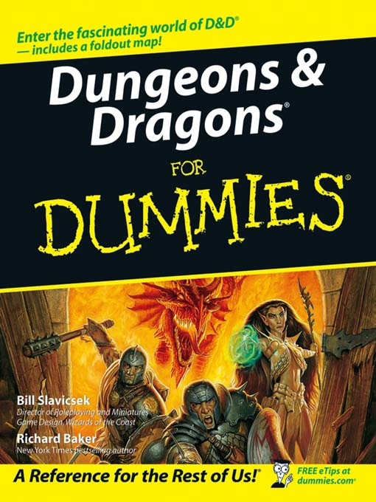 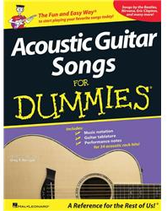
Font downloads: (located in the Photoshop fonts folder on the H drive, so you can copy and paste the TTF files to your computer, My Computer, C drive, Windows folder, Fonts folder)
Dummies font http://www.fontspace.com/category/book
Baar Sophia (would work for headlines) http://www.urbanfonts.com/fonts/Baar_Sophia.htm
DUMMIES BOOK COVER SCORING GUIDE
Setup:
- Start with a regular letter sized page size (8.5” wide by 11” tall, 150 resolution); however, when you print, you will print at 90%.
- Fill the background layer with yellow.
- Create a “cartoon” dummies man using the pen tool and shapes tools. He should resemble the original dummies guy, but have your own personal touch. Do not use any clipart on the cover, only shapes or draw with the pen tool. Be sure to keep all his parts in a layer folder/group.
- Include an image that represents your topics. Parody is fine (encouraged) so have fun with it!
- An intro/teaser line is included the top of the cover that describes the book.
- A colored shape must be included that provides additional information about the book, included materials, or bonus “stuff” that comes with the book.
- The “A Reference for the Rest of Us!” line must be included at the bottom.
- The traditional black text box with white heading and yellow “for Dummies” in appropriate font.
- Yellow divider line.
- Your name listed as author with short tagline about “your qualifications” for this book’s content.
Requirement | Points Possible | Deductions
Letter sized paper, printed at 90% | 5
Yellow background with correct “title” box (black box, yellow bottom line, white and yellow text in matching fonts) | 5
Cartoon dummies man created from shapes/pen tool used on cover | 10
Intro line is suitable for book | 5
Colored shape included with text about book and fits with overall color scheme | 5
Tagline at bottom as required is included an appropriate matching font/color | 5
Your name listed as author with pertinent qualifications over a related image (HQ) | 5
Spelling/grammar | 10
Overall professional appearance, clear images, easy to read | 10
TOTAL | 60

Book Title: _____________________________________________________________________________
Student Name: ___________________________________________________ Hour:______

