Fun Fonts Poster—Typography Project
Create a poster that utilizes numerous font types—sans serif, serif, script, and decorative/display. The poster should include either a specific theme, lyrics to a poem or song/chorus, or otherwise incorporate something meaningful to you. Other requirements are listed below.
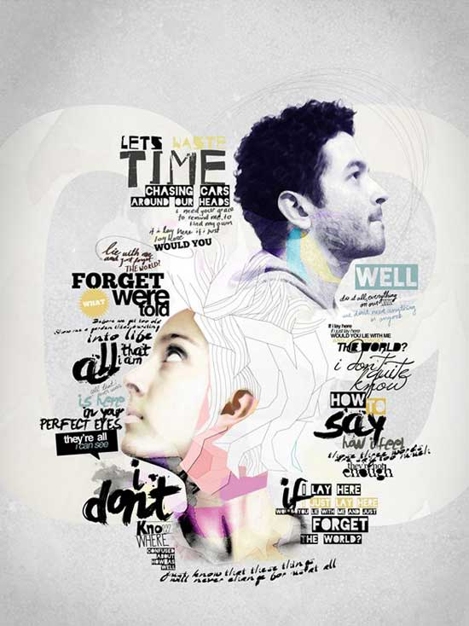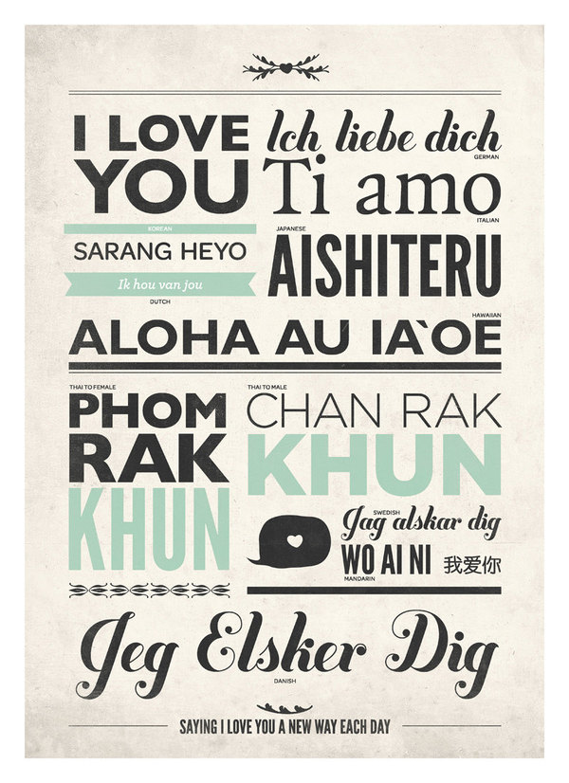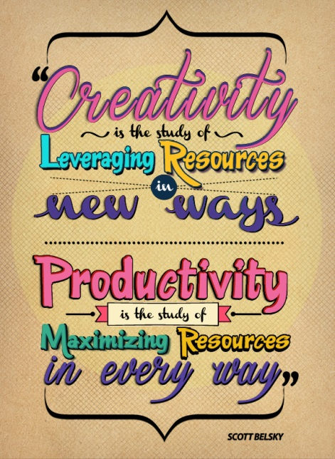
Requirement  -----Set paper size to 7.5” wide by 10” tall; print at 100% scale in color! | Points Possible | Deductions
Background texture created using:  - Solid color background layer  - (higher layer) Custom, loaded brush (cracks, smoke, textures) with blending mode applied | 5
Vignette effect around edges; use a soft, big black brush on a layer above the background layers to “burn” the edges/corners (if using a light background, this can be a suitable color for the effect) | 5
At least 2 custom shapes (banners, dividers, etc.) OR custom brushes  List which were used (loaded from Z drive) | 8
At least FOUR different types of fonts. List the font used for each of these categories. If you used more than one, you do not need to list more than one:  - Sans serif:__________________________________________  - Serif: __________________________________________  - Script/Handwritten/Scribble: __________________________________________  - Display/Decorative: __________________________________________ | 8
Character Panel: Modification of text spacing—kerning or tracking—in at least TWO places AND/OR use of horizontal or vertical scale adjustment. List where and whether it was negative or positive  - ____________________________ + -  - ____________________________ + -  - ____________________________ + - | 4
Creative use of fonts that show emotion or tone and use of at least one warped/curved text | 10
Professional appearance—remember, that text has to be the focus of this piece, but you can use other images if it does not detract from the focus; utilize rotation, blending modes, clipping masks and layer styles as needed | 10
Spelling | 10
(Save JPG for Web to Portfolio folder and upload!) TOTAL | 60

