Photoshop—Camera Training

Videos
In the Photoshop folder on my drive, there is a Camera Training folder. Pick one of the cameras to play with and then find the appropriate videos by Seezmo. The Canon Powershot G12 cameras users should watch the G11 video. The Canon Powershot G15 users should watch the G15 videos. Watch in this order:
- G11—Getting Started-Basic Picture Guide (watch this regardless of the camera)
- G15—Basic Overview (watch this regardless of the camera)
- G11—Macro Guide or G15—Macro
- G11—Sports Guide or G15—Sports
The videos will take about 25 minutes in total to watch. However, I encourage you to use the class period to its fullest and pause/rewind to try out the settings. It is important you get comfortable with the camera!
Please make notes on these sheets. You will be quizzed over the camera concepts and may use this packet.
G12 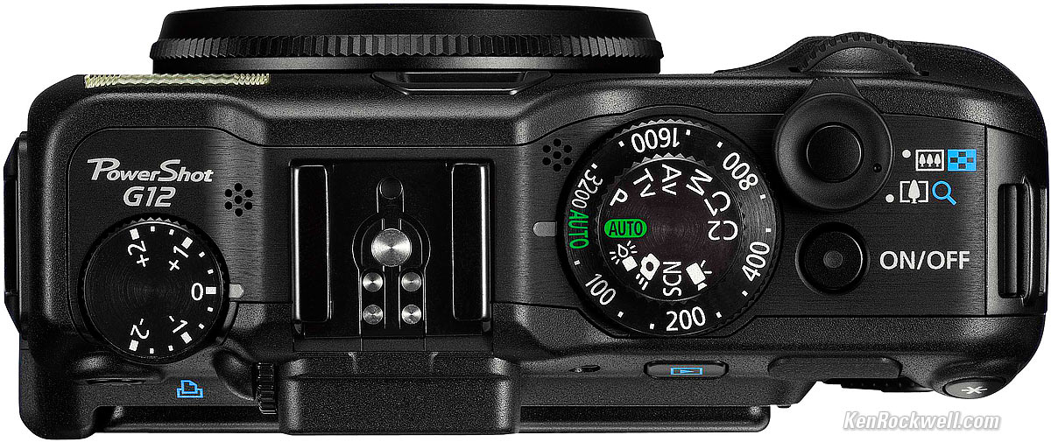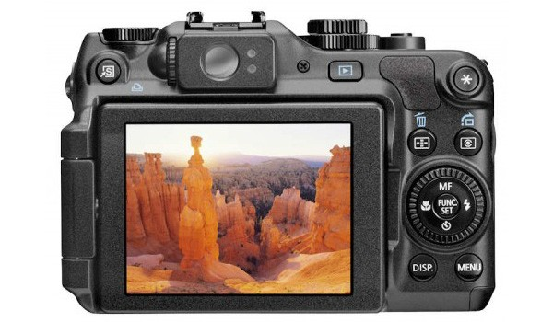
G15 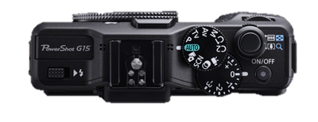
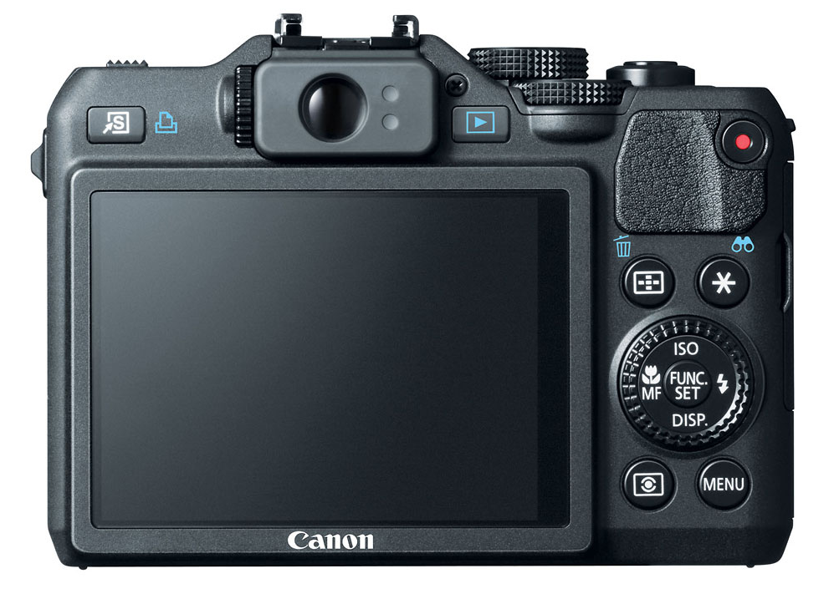
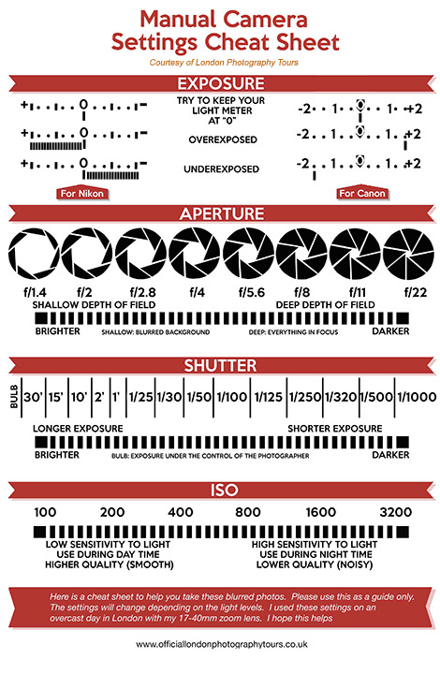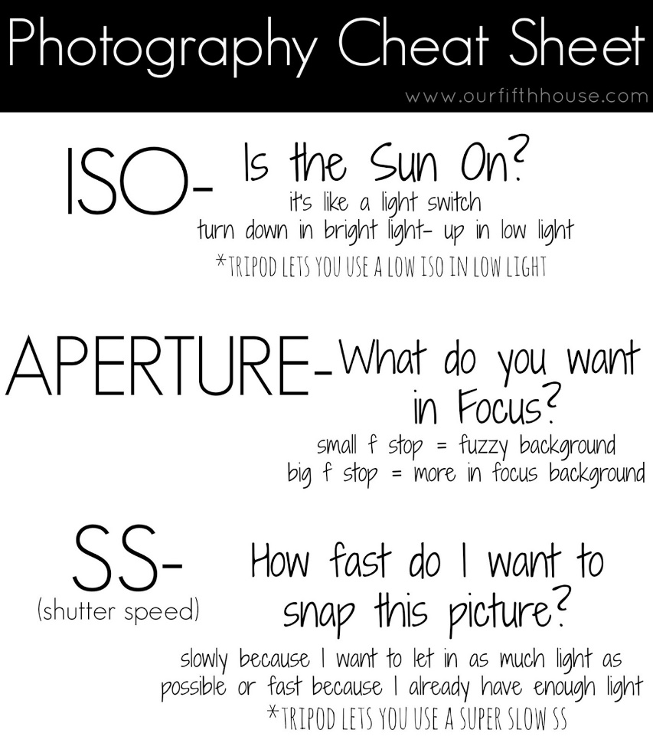

Getting Started/Basic Overview (watch both!)

- What mode on the shooting dial is labeled SCN? ________________
- What is a “hot shoe” used for? ______________________________________
- The blue icons on the back of the camera are for use during __________________ mode.
- It is best to use the ______________ mode instead of the Auto mode for shooting photos.
- To prevent shadows on a face in a bright daylight situation, you should __________ the ____________ to fire.
- To access the Function menu, press: ____________
- To get the best look at what your camera is taking a picture of, look through the _____________________.
- To lock in focus, press the _________________ _____________ _______________.
- Once the square in the middle of the screen turns green, it means that the ___________ is locked.
- The button you press to actually take a picture is called the _____________ button.
- To double check the clarity of an image, you can ____________ while in playback mode.

Macro

- To take macro pictures, it’s good to set the camera on __________ mode, not Auto.
- Press the ___________ button (icon) to enable macro shooting (for when taking close-up pictures).
- When shooting macro pictures, you should NOT be __________ in at all.
- You should _______________ step closer to the subject to take macro pictures.
- If you are closer than ____ feet, turn off the flash.
- To access Flash Exposure Compensation (make flash stronger or weaker), you should press ____ button, select Flash Exposure Compensation (), and adjust the dial.
- To access white balance, you might choose AWB (which stands for __________ white balance) or you can set it on Daylight or Clouds for outdoor shooting or Tungsten or Fluorescent for indoor.

Sports

- Sports scene is a feature accessible under the ______ button on the dial. It tries to set the shutter speed quickly and drive mode so it can take multiple pictures.
- Another way to set Sports shooting is to use ____________________ mode (Tv). This lets you set a fast shutter speed, such as 1/250th or 1/500th of a second.
- For Sports, you should have the flash turned ______.
- The Drive mode lets you take pictures continuously. You can hold the shutter down and the camera will _________________________. Continuous Auto Focus mode will _________________ before taking each image.
- ISO controls how much _______ gets into the camera. But, a higher number can cause noise.
- Manual focus is not going to work well if a subject is running _________________ you.

REVIEW

This shot would be an example of _________________________ photography.

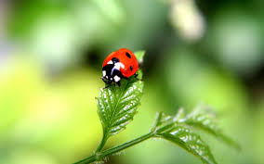

For sports shots, it is helpful to set a fast ______________ speed but you may have to increase _____ if you don’t have adequate lighting.

Light Painting Fun
Watch the video on how to do light painting with a Powershot camera. You have to shoot in manual mode. They suggest these settings: MANUAL mode, Shutter of 6”, f5.0 aperture, and ISO low (80-100). They suggest a self-timer so you can reduce camera shake from pushing the shutter (when you push the button, the camera jiggle slightly). Remember, it will shoot open for 6 full seconds, so it “record” the motion that happens in that time and translate that light into a streak.
Prepare equipment, get light items (flashlight, small lights, etc.), find a dark room or dark space, put camera on a tripod. Then, you can take the picture with the self-timer.
(NOTE: long photography trick video with the apple used 100 ISO, 15” shutter, f11 aperture)
NOTES:

Long Exposure
You sometimes see those cool long exposure shots that are of cars speeding down the road. To do that, suggested settings:
-2 exposure, ISO 80, 15” shutter speed, White Balance on Daylight, self-timer to 2 seconds (to reduce hand shake), and Tv mode (shutter priority) and a tripod.

Photography Portfolio Assignments

You are not required to have all of the items below. You are encouraged to get a minimum of 8 good shots and maximum of 15. You can have more than one per category. Remember to examine the EXIF data when writing responses.

Check | Picture Illustrates | Helpful Notes | Your Notes
 | Macro w/shallow Depth of Field (blurred bg) | Be sure subject is not close to the background; use a low f-stop (f1.8 to f3) and avoid flash
 | Portrait w/shallow Depth of Field (blurred bg) | May have a camera setting for this (SCN) but similar to macro except subject is a person. Stand back when shooting and be sure person is away from background.
 | Comparison picture of same image with one a shallow depth of field and one a deep depth of field | Aperture Priority mode; take one with a low aperture (f2; small depth of field=blurry bg) and one with a higher aperture (f10; large depth of field=most of the image in focus)
 | Silhouette | 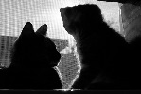Shoot this in full manual mode. You want a light source behind your subject, no flash, and fast shutter speed.
 | Perspective (high or low angle) or  Forced Perspective | This technique is all about controlling how the viewer will interact with your image by deliberately telling them how to view the subject. This is done by shooting from different angles and engaging your subjects from different points of view are creating an illusion.
 | Rule of thirds | 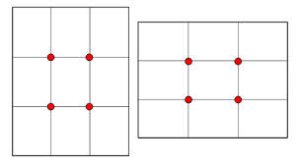This “rule” divides the image into three parts both vertically and horizontally, giving many different focal points that can be used in an image to really draw the viewer in.
 | Framing | 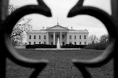Using other objects in your photograph to frame the main subject
 | Filling the Frame | Fill your entire image with what you are photographing without any outside noise or distraction. In other words, get in close and cut out any distracting background stuff that may distract from your main subject.
 | Action “freeze” shot  (fast shutter, lots of light) | Shutter priority mode—fast 1/500+
 | Light painting (long shutter) | Full manual mode for this; long shutter 5” or more; high aperture number=small hole (F10+); tripod
 | Other:

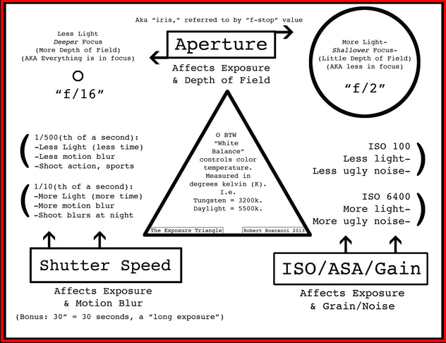
Upload these to a new page on your portfolio and write about how each one illustrates the concept.
Name:____________________

