Photoshop Magazine Ad Project…. Featuring YOU! NAME:________________ HR:___
PROJECT OVERVIEW: Select a brand or a store, not a product, which you LOVE to buy (or buy from!). Create a one-page full magazine ad that involves a full length YOU cut off your background. You must include the company/brand logo, two shapes, a handwritten type font for the text on the path. Include a phrase that would be your “quote” on the ad. Like this example, the phrase must follow a non-standard path. The background must stay simple—a solid color is fine (black or white always are good), lightly burned or colored edges or faded gradient works, or even a muted texture. Nothing complicated. This should be a professional looking design suitable for a magazine that people your age would read. Be mindful of your camera angle on your shot (I’d suggest having the person taking your shot hold the camera between waist and shoulder level and shoot straight on—no angles up or down unless that’s your specific effect).
Upload to Snack Website for grading; do not print. Turn in this page to the tray when published. Be sure to include reflection.

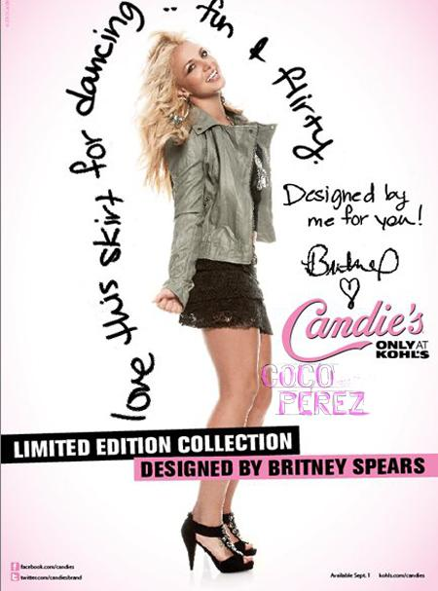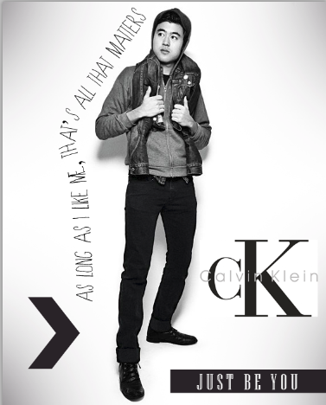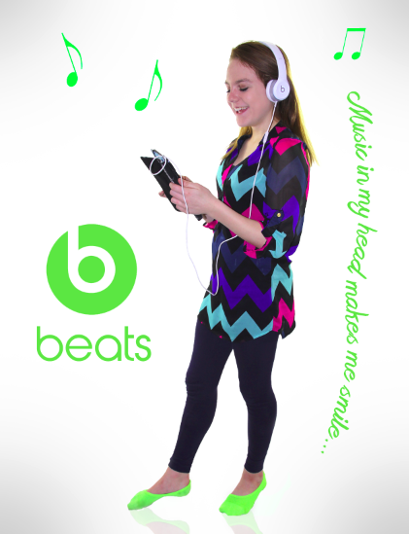

Requirement | Points Possible | Deduction
Photo of you as subject is clear and in focus, levels adjusted, retouched as needed, with high quality background removal | 10
Company logo incorporated into project; high quality | 5
Use of at least two shapes from the Photoshop custom shapes that match overall color scheme and tone | 5
Quote or phrase in handwritten-looking informal font and is readable | 5
Type is done along a path or using suitable text transform to go around the photo in a non-standard way; kerning adjusted as needed between letters in any awkward spots | 5
Overall appearance (looks real, professional, magazine quality) | 5
TOTAL | 35
SNACKWEBSITE ADDRESS

