MOVIE POSTER PROJECT--Part 1
Create an 8 inch by 10 inch document in Photoshop. Create a movie poster “spinoff” starring YOU!
Required photos:
- At least two internet photos (must write down the URL of where the photo is located online)
- At least two photos you take
- At least one photograph of you
You select your own poster, but it must include “advanced features” and require some thought to recreate. For example, the Braveheart poster would be just fine. Drillbit Taylor would not be fine!! It’s too easy, basic, simple… you get my drift. Find something HARD!! Yours does not have to be an exact replica, but it does need to have features and be set up like the original (your photos may be of different things). I encourage you to spoof (make fun of) the movie, though (think Scary Movie).
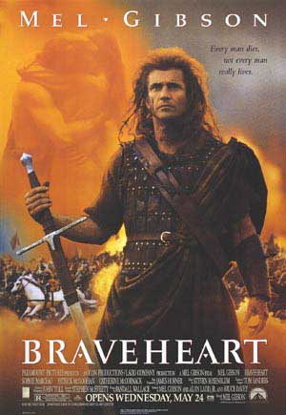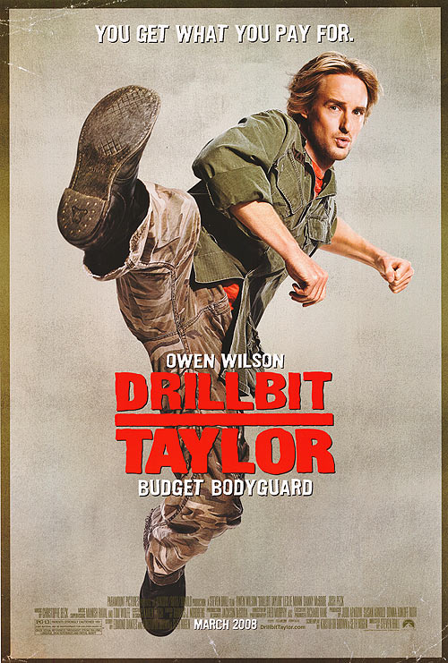
Assignment #1: Locate two potential movie posters you think would be good to recreate. Copy and paste them (two to one page) and print IN COLOR to turn in to the tray today. WRITE on the copy and indicate where you see certain features we used in the previous project (20 points). Staple to this sheet.
http://www.movieposter.com/ http://www.impawards.com/
Name:__________________________________________

MOVIE POSTER PROJECT--Part 2
Assignment #2: Gather all required photos for your project. Write the URL’s below for the internet located photos. It should be the ENTIRE address (click onto the picture if you are in Google and find the exact page, not a big long address that starts with Google) so I could go straight back to see the photograph if I wanted to.
Create a folder on your computer and put all these photos in there. Be sure to gather everything you are going to use! You may not add additional photos later!
Insert each of your required photos onto a page (in Word or PowerPoint or print through Windows), with 2 per page. Print and staple to this sheet.
Photos I am Going to Use
Photograph of… | Located/Taken by/Acquired…

FONTS
Thinking ahead… what FONTS would you like to use? Look through the fonts and get some ideas. List your fonts below (if you downloaded a new font, please indicate that by placing a star next to it). LIMIT FONTS TO NO MORE THAN 4! (probably 2-3 is enough)
Font Name | Using for…

Name:_________________________________

MOVIE POSTER PROJECT--Part 3
Assignment #3: Create your project! Set up as follows:
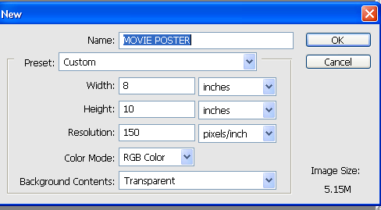
Be sure to save frequently as you work, and be sure to save in PSD format so you maintain layers. You are required to NAME layers, and I will have you print a screenshot so I can see that layers are named AND do spot checks of screens to ensure you are naming. Remember, you can “eyeball off” layers so you can’t see them, if needed, while working.
By now, you should already have all your fonts selected, photographs obtained, and you know what you want to do. Sketch it out below (doesn’t have to be perfect) noting effects you plan to use:

Call teacher over to approve your sketch BEFORE you work on the project in Photoshop. For ideas, see back of this page for links to Photoshop Tutorials.

Teacher Approval:_________
Date:______________

MOVIE POSTER PROJECT—SCORING GUIDE
Use this as a guide while you work. Remember, your project should demonstrate your proficiency with Photoshop. If there is something you do not know how to do, ask and I will try to direct you to a tutorial on a website that can assist you or you can Google the idea yourself.
Some tutorial websites—
http://www.photoshoproadmap.com/Photoshop-blog/ (has 70 horror/gore effects, 100 wonderful photo effects, best 80 text effects; some are for different versions of Photoshop, but you should be able to adapt)
http://www.webworksite.com/photoshop_elements_tutorials.shtml
http://www.escrappers.com/photoshopatoz.html
Requirement | Points Possible | Deductions
Correct page size; printed in color to full page | 5
Demonstrates use of various sizes of brushes, erasers, textures, etc. | 10
Good use of text/type and type/layer effects (gradient, bevel, drop shadow, etc.) | 10
Includes layer and/or color adjustments (hue/saturation, brightness, contrast, etc.) and LIST BELOW: | 20
Quality of cropping (be sure to zoom closely when cropping and alter tolerance on wand) | 10
Realism | 10
Spelling/grammar | 10
Overall similarity to original | 10
Improvements/originality | 10
Overall quality and professionalism | 20
PRINT ORIGINAL PHOTOS/IMAGES 4 PER PAGE  (pic of you, internet photos, etc.)  Write under each photo where it was obtained!!! URLs must be included!!! | 30
SCREENSHOT of your LAYERS palette printed  Layers should be named and organized! Expand it so you can see them all. | 15
TOTAL POINTS | 160

Name:_______________________________________ Staple your finished papers to this!
You should have THREE color printouts stapled to this sheet!!!

