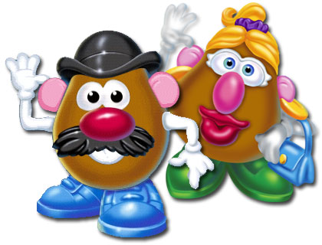
Mr. Veggie Head—Photoshop Selections Practice

- Copy the VEGGIEHEAD folder to your Classwork folder. Then, open potato.jpg as your base image.

- There’s not really enough room to do much here, so let’s enlarge the canvas (Image> Canvas Size) to 15 inches wide and 20 inches tall, white background.

- Delete the background off the potato image (HINT: Unlock background, delete after selecting with magic wand)

- Save as and save in PHOTOSHOP PSD format to your VEGGIEHEAD folder as MyVeggieGuy.psd and keep working.

- Open veggie1.jpg and make the following selections, dragging each to the base potato:

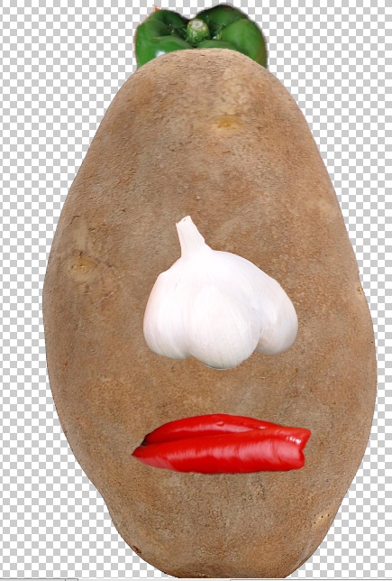
  - Select (Quick Selection) the white onion on the middle of the page, refine edge, and move over to the potato as the nose
    - Note, when moving to the next selection, be sure to deselect first (Control+D)!
  - Select (Quick Selection) the red pepper on the left of the page—but it will probably not select well and pick parts you don’t want, so zoom up and use the Quick Selection brush on MINUS to remove areas you don’t want, refine edge, and move over to the potato as the mouth
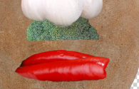
  - Select (Quick Selection) the green pepper on the middle of the page, refine edge—but adjust the radius and modify shift edge to negative if needed to remove any red halo, and move over to the potato as the hat; move layer so it is behind the potato
  - Select (Quick Selection) a part of broccoli on the image at left. Refine edge and move over beneath the nose to create a mustache
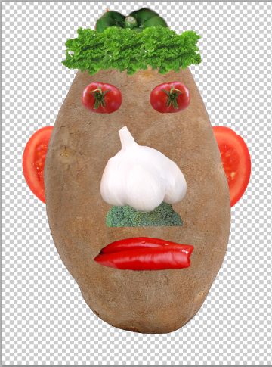
- Open the tomatocross.jpg image. Select the cross section of the tomato using Quick Selection, then remove half of it by using the “subtract” mode of the rectangular marquee tool. Drag this over as an ear and position beneath the potato layer. Repeat this process for the other half so he has two ears.
- Open the tomato.jpg image. Select the tomato that is in focus. You may have to subtract from selection to properly select it. Refine edge and then bring over to the document. Position as eyes, rotated as shown. Duplicate the first eye (or drag over another copy). For the second copy, you will mirror the eye so the green part is opposite (Control+T to transform, right click inside the transformation, Flip Horizontal).
- Open the lettuce.jpg image. Remove the background using the magic wand. Drag over for the hair. You will need three copies, but this time, hold Alt while dragging to duplicate.
- Name all layers.
- Create a layer group/folder called HAIR. Move the three hair layers into that group.
- Open the fire.jpg image. Drag in to be used as the background. Move to the bottom of the layer stack.
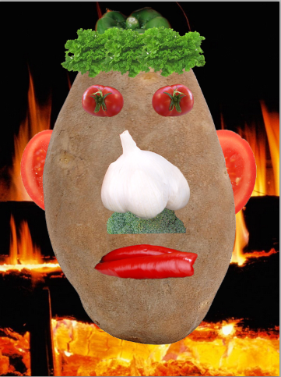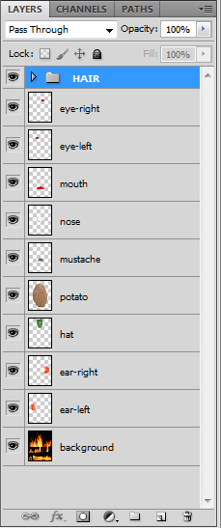
TEACHER VERIFICATION—DO NOT PRINT
Be sure your layers are named. Add your name to one of the corners. Transform it so it rotates up the side. Add a drop shadow or glow (whichever shows better) so I can see your name better (HINT: fX button). Then, call me over to see your screen. You can add additional veggie items if you wish… yeah, do it.

