Photoshop Typography
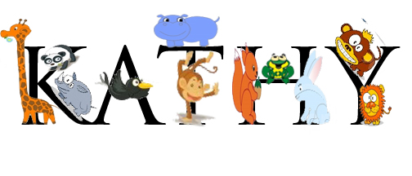
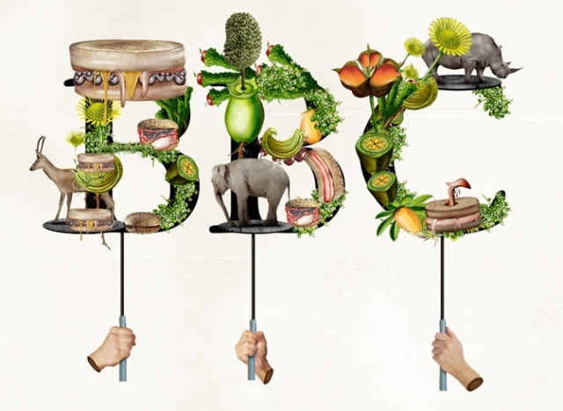

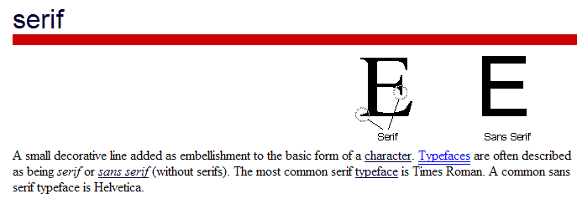
What you need to do:
- Create a NEW Photoshop canvas dimensions 8 x 4 inches
  - Make sure background contents is set to WHITE and Color Mode is set to RGB
  - Save to a folder called Type on your U drive.
- Pick a SERIF FONT and type your first name as big as you can make fit!
- Choose a THEME (animals, food, flowers, anything you like)
  - Search for usable pictures online; be sure they are good quality! And, they all need to be the same type of graphic—either all cartoons or all photographs or all clipartish stuff… not a variety).
  - Save all the pictures you want to use in a folder called Type on your individual U drive.
  - Open the pictures in Photoshop, using the various techniques covered so far in class, move the individual images over to the canvas with your typed name—DO NOT USE ERASER! Try to use magnetic lasso (refine edge before you move it over!) and/or refine with masks.
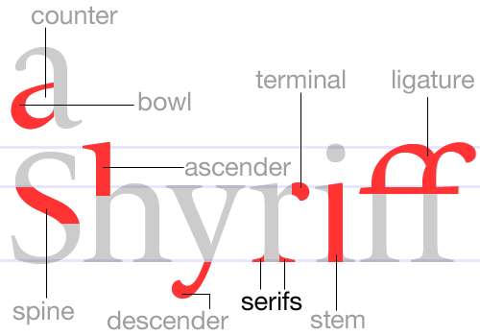
- Place your pictures/graphics (should be one or the other, no mixing!) on top of your typed name.
You are creating a layered object.
  - Each of your pictures/graphics should ‘sit’ on one of the serifs, stems, spines, or descenders of your chosen fonts. (look at the graphic to the right if you don’t know what serifs, stems, etc. are!)
  - Remember, the goal is to create an original and creative Typography Font Art. Your name should be covered with pictures/graphics, but should still be recognizable!
  - Use masking to make some images appear to wrap around letters (or vice versa) by duplicating the images (one above the type and one below) and masking the “in front of part” on the top most layer out).
- Save your PHOTOSHOP FILE (.psd)…then do a FILE, SAVE AS and save your project as a JPG and upload this file to my class site listed below.

Criteria | Points | Deductions
Canvas Size 8” wide-4” tall | 10
Name typed with a font that has serifs (the more the merrier!) | 10
Easily identifiable THEME | 10
High Quality pictures/graphics | 10
Backgrounds erased from all images—overall quality of selections | 10
Pictures/graphics placed on required portions of the font (serifs, stems, spines, descenders) | 10
Mask used to “wrap” part of the text with images | 10
Name still recognizable | 10
Saved as Photoshop document (PSD) Screen check layers: ________ | 10
Saved as JPG on picoodle.com (login is skindawg, pw is student) | 10
Total Points | 100
Name:_________________________________

