Fantasy Human Project
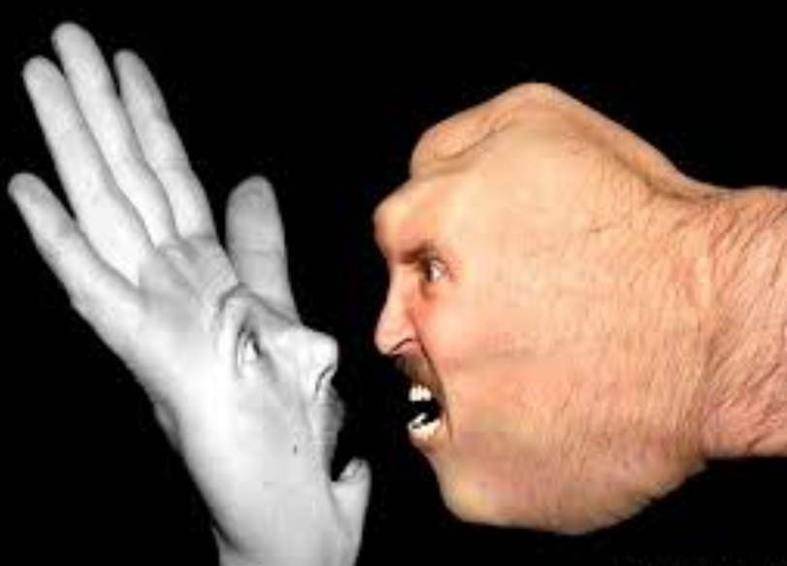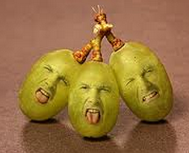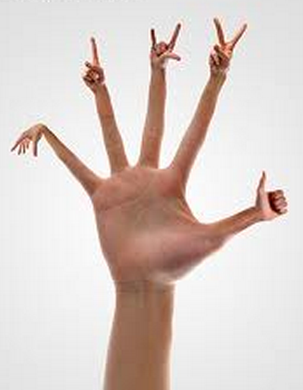
For this project, you must use at least four images and two must be of two of your body parts (face, ear, legs, arms, hand, etc.). The main goal here is to make something that looks fantasy, but realistic. This will require modifying skin tones (consider using the Photo Filter adjustment) or hues (Hue/Saturation adjustment), blending modes and very soft brushes on masks. My biggest advice is to be sure to think about the angles necessary when you take photos, select and pull over more than you need where you plan to “attach” something, warp transform gently to match up edges and zoom up closely to touch up your masks. Have fun with this! Use fun expressions or awkward poses… it’s just more awesome!
Requirement | Points Possible | Deducted
Uses at least four source images—print contact sheet | 8
Two images are of you—photos are of what? ________________ | 4
Quality of selections (be sure to bring in hair, keep contrast up, don’t have fuzzy edges except where needed to blend) | 10
Realistic use of masks for blending  Teacher verification of masks ____ | 10
Overall quality/creativity | 8
TOTAL POINTS | 40

***Demo video available if you need it! Fantasy Face Fun!***

