Photo Hashtag Campaign (via Photoshop!)

On Celebrity Apprentice, they were tasked with creating a photobomb campaign. Here are some tips for a great campaign along with two examples from the show for Kings Hawaiian rolls:
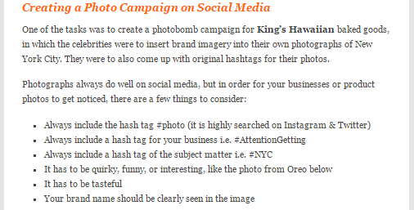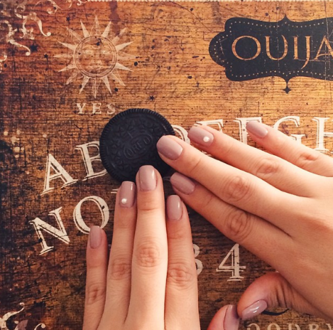
Tips from http://attention-getting.com/2015/02/03/marketing-dos-donts-from-last-nights-celebrity-apprentice-3/
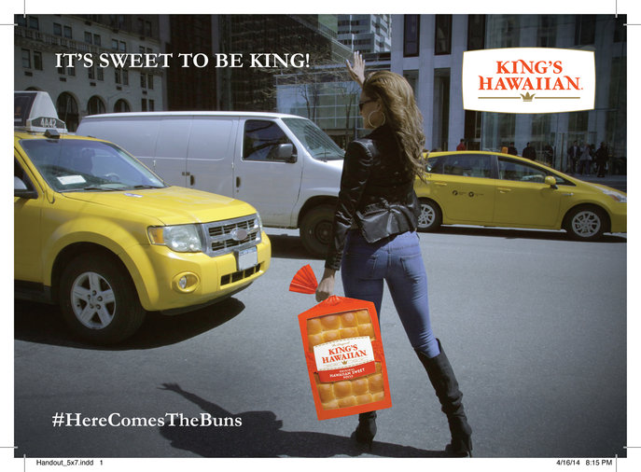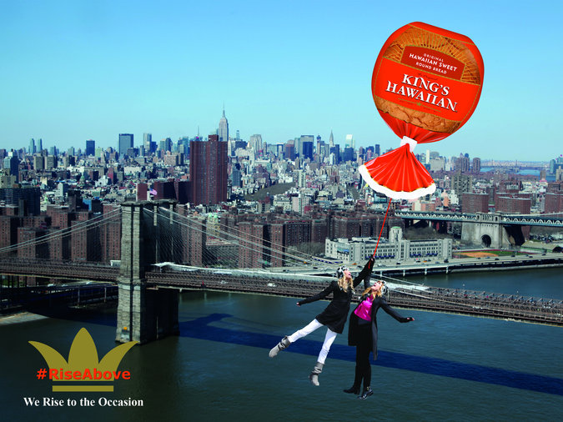
More examples here http://www.nbc.com/the-celebrity-apprentice/photos/kings-hawaiian-photobomb-photos/2219536

Cooperative Activity:
Working in your assigned neighborhood, you will develop a marketing campaign for a product that appeals to teenagers. Your group of 3 to 5 students will pick a specific company and product and develop individual campaigns around that company and selected product. Each of you must design at least 2 different electronic campaigns that include the product “larger than life” or used in a unique promotional way, and the group must use the same hashtag and logo on each design. You may design more than 3 if time permits, but the “best 2” will be graded.
According to Target Marketing Magazine online, “Teens between the ages of 16 and 17 spend the majority of their money on clothes, shoes, jewelry, sporting equipment, entertainment, health and beauty aids, and food, according to a recent study conducted by market research firm Harris Interactive KidPulse.”

Once completed, your group will present your concepts to the class using a Google Slides shared presentation. Select a group leader to create the initial slideshow, which will include the color scheme and basic design. The slideshow should be shared with EACH group member and your instructor through Google. As you complete your designs, you will post the portfolio/JPG version on the slideshow. Be prepared to discuss your part of the marketing project in front of the class.
Group Leader: ___________________________________
Other Members: ___________________________________________________________________________________
*** Put a star beside your name
Our Product:_____________________________ Our Marketing Hashtag: _________________________
SCORING RUBRIC
Criteria | Pts Possible | Pts Deducted
Group selected a suitable product that would be appealing to the target audience | 5
Both designs utilize the group hashtag; font is readable, bold, and grabs attention | 6
Both designs include a product logo in a way that the company would appreciate; integration and placement makes sense; the logo is clear and high quality | 9
At least TWO high quality items/products are Photoshopped into the composite and selection is clean --quality of selection and realism are critical for full points! | 16
Overall idea concept (creativity, interesting, and overall professional look)  --includes creative slogan, wise use of fonts, etc. | 6
PRESENT: Student included their concept on the group Slides presentation (2 designs) | 8
PRESENT: Student spoke about their concept and provided sound reasoning for design choices; vocabulary used demonstrated Photoshop knowledge and competency; student used appropriate volume for delivery and showed enthusiasm | 10
TOTAL | 60
Feedback

**Include your two designs (JPG versions) on one new post on your Snack Website called Photobomb Campaign; in your reflection, discuss your group dynamic in addition to regular requirements. If you can figure out how, embed your Google Slideshow onto your reflection page!

As you create your design, get feedback from your group members. Ask others to come and look at what you are designing to see if they feel it has the proper professional vibe and suitable quality. As a group member, it is your responsibility to provide helpful, constructive criticism to your group members.

