BE A HERO PROJECT
That’s right, it’s time for you to step up and be a hero! For this project, you will use two pictures of yourself and some pictures from the internet to create a realistic “superhero” split-screen scene! Create a new Photoshop file in landscape orientation—10” wide x 7.5” tall, 150 ppi resolution, print at 100% scale in landscape.
Ideas for superhero: fighting evildoer, leaping tall buildings, flying, using super human strength.
Requirement | Points Possible | Deducted
Two photos of self; one in normal, everyday student pose (by lockers, studying, etc.) and one in superhero action mode/pose; hero selected cleanly and removed from background (think Clark Kent vs. Superman) | 10
Choice of superhero action -- some special feat (using power) | 5
Created a superhero crest for the cape or chest; placed in location and skewed appropriately to look real (blended with colors/changed blending mode as needed) --must include text on a path or text warping, a shape, and gradient or pattern overlay-- | 10
Quality of photographs obtained from internet—must put together groups of photos for hero scene (cannot take a complete background or existing super hero photo and just put yourself in it) | 10
Embossed logo (hero crest) included on ‘non-super’ split side of project | 5
Text added (Student by Day … Superhero by Night!) with at least two layer styles applied (fX) in unique font | 5
Overall realistic appearance (clipping mask each part into a triangular section) --be sure the student picture is taken where you can cut off the bottom right part! | 10
Contact Sheet printed with all source photos used | Required/10 deduction!
TOTAL --print and upload to portfolio with written response | 55

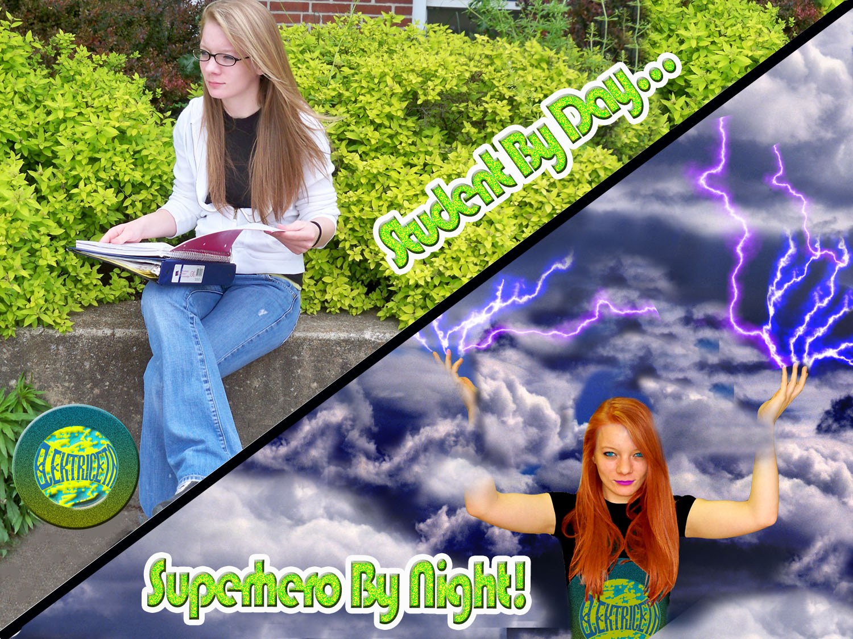
logo

Name:_________________________________ Hour: ____

