Photoshop Wallpaper Name Project
Download the starter file off the class website wallpapernameproject-start.jpg
Locate a texture that you will use inside a clipping mask of your name from this website
http://www.textureking.com/index.php/category/grunge
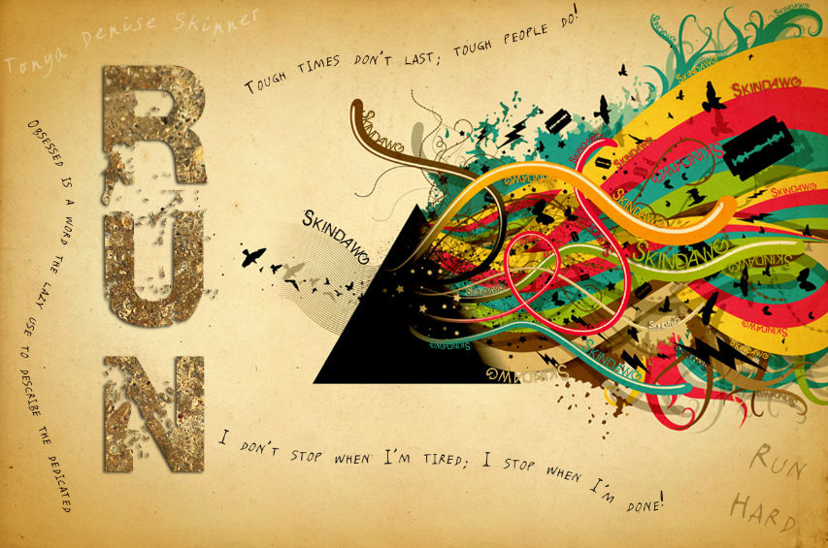
Concepts to demonstrate:
- Pen tool and paths
- Clipping mask
- Vertical type
- Shape paths

Requirement | Points Possible | Deductions
Required background image used | 2
Large vertical text of name or theme on left (or nickname, etc.)  ***Use a very thick font and add a drop shadow for effect (fX) | 3
Texture (grunge type) brought in on new layer and used as clipping mask inside vertical text | 4
Wavy path text included (at least three) --transparency optional--  ***May use clipart and convert to paths or draw with pen tool | 6
At least 15 text on a path added to the swirlies on the right side of the background; text color should match the color of the line it follows; some should be right side up and some upside down and font sizes should vary; use font consistently (no more than 2 different fonts in the swirls area) | 30
Drop shadows and/or glows are added where necessary to emphasize text on similar colored background (fX) | 5
Overall appearance; clarity of fonts and color matching to theme | 5
Total Points:  Print in color, landscape; staple with scoring guide on top | 55

*Remember to Save for Web in JPG format to your portfolio folder!

Name:_________________________________________ Class Hour:_____

