Name:____________________________ Hour:_____
THINK BIG POSTER ASSIGNMENT—Print in color (no contact sheet required)
Create a new Photoshop file. It may be one of TWO sizes:
- 11 x 8 ½ inches (letter landscape) at 150ppi resolution
- 14 x 8 ½ inches (legal landscape) at 150ppi resolution (will require legal paper to print)
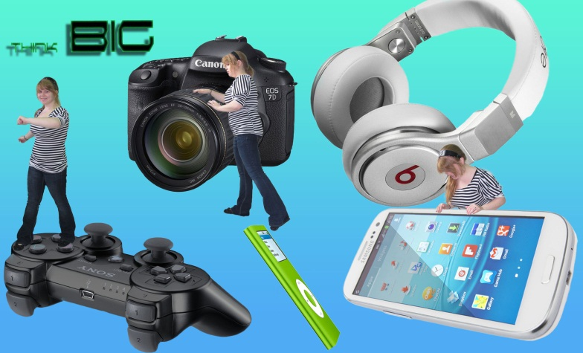
Take three photos (or have three photos taken of you…just use classmates if you wish). You may not use old photos; take new ones for this project specifically after you select your objects! You must take three POSED photographs that suit the project.
Locate a minimum of FIVE objects to include in your poster. The poster will show those objects as close in scale to each other as possible. Use masks to “hook” or “hang” objects realistically. Your people should be “Stuart Little” sized; they should stand roughly half or more high on the page. Do not make them too small!
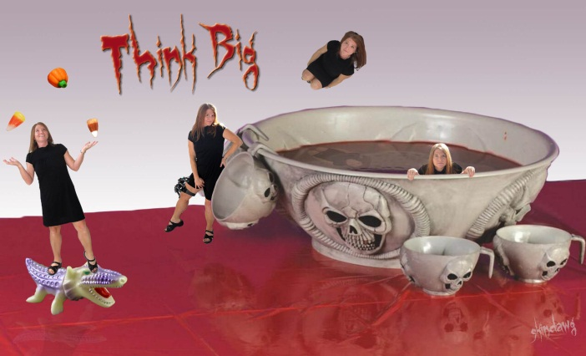 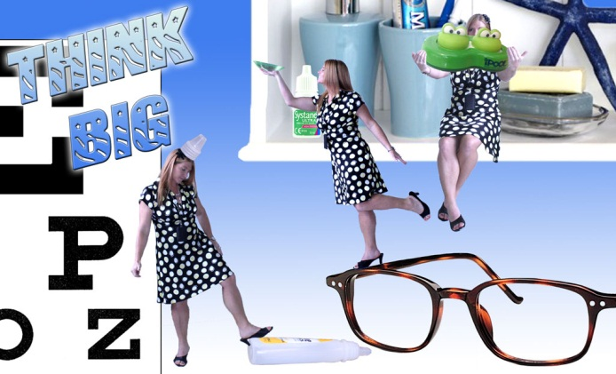
This project is scored on:
• Follows instruction for page setup: 5pts _____
• Three unique posed photographs: 6pts _____
• Quality of selections (touch up!): 10pts _____
• Five objects to scale, high quality: 10pts _____
• Gradient background (minimal; not flashy): 4pts _____
• Phrase “THINK BIG” with two layer effects: 5pts _____ TOTAL: ______/40

