Photoshop Surrealistic Project: Water Box
This project can take root in fantasy a bit, so feel free to be creative and think outside (but inside…) the box. You will create a scene using a sky, water, water brushes, at least two images obtained from the internet, and a full length photo of yourself.
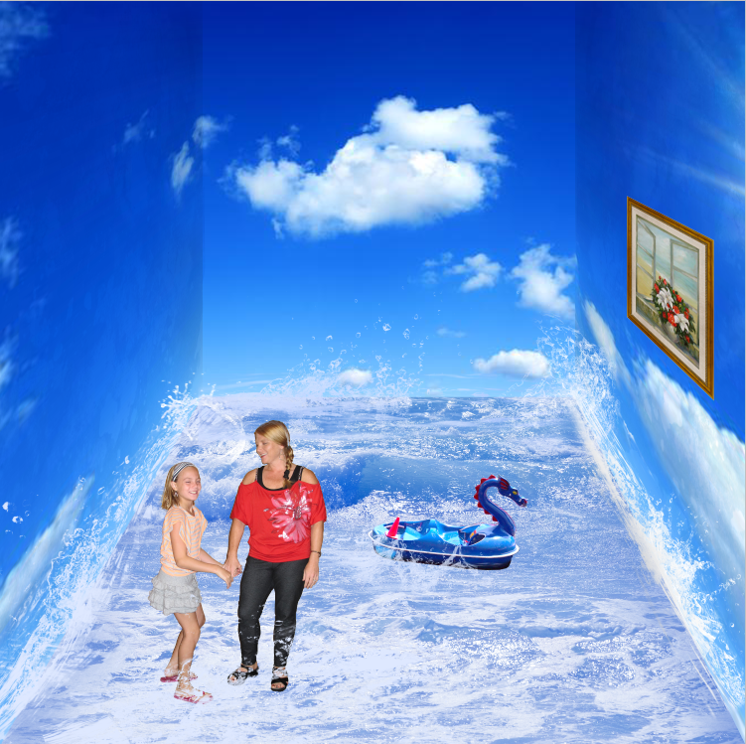
Requirements--- Upload to portfolio, but no written response required | Pts | Deducted
Page Setup—
7.5 inches by 7.5 inches square with 150 resolution
Large sky photo, subdivided with left and right (Layer via Copy) and skewed to the corners; quality of division (use guides) | 10
Sky corners “burned” gently to show the corner lines; may wish to “dodge” edges on the water feature if needed | 5
Water/ocean feature added as bottom layer, with appropriate color tones | 5
Image of student and one other object added to water feature; at least one object added to the “wall” of the sky, transformed for depth | 10
Waves brushes used to create splashes at seams and around objects | 10
Optional: Texture added to sky “wall” (consider vintage paper brush set, stamped on higher layer, with Multiply blending mode) | 0
Overall quality of image selections, depth/shadows, and use of waves | 10
TOTAL POINTS | 50

Name:_________________________________ Hour:____

